## COVER PAGE TITLE GOES HERE

## JD’s babbitt bearings technical specifications

## Solution architecture

### Database Project

For keeping tables, stored procedures, and other database entities up to date

### Web Project

For controllers, views, and client side scripts

### Model Project

For the data model and any view models needed in the UI

## Development Environment

The web portion solution will be developed using Microsoft Visual Studio 2013 in C# using .NET 4.5.2. Solution files will be source saved in a locally hosted Microsoft Team Foundation Server (TFS) and tasks will be logged in TFS appropriately. Source files will be managed with a strict check-in check-out policy and file version control will be implemented. Local database testing will be done using Microsoft SQL Server 2014.

## Hosting environment

The Web Application and Database will be hosted on premise in a climate controlled server room. If a customer portal is required, considerations will be made to host it on Windows Azure. There will be a public-facing customer job status page that will be hosted in Azure, along with an Azure database to support it.

## Data transfer

Communication between the Web Application and the SQL Database will be through the use of Entity Framework. This reduces the risk of malicious database manipulation and increases the efficiency of coding, maintenance, and data access.

Secure Socket Layer (SSL) cryptographic protocol may be used to ensure that the data transferred between the web server and the device is encrypted. Data transfer between the locally hosted database and the Azure database will occur as the data is updated locally and will be done by the web app.

## Third party solutions

### Twitter Bootstrap

For user interface styling; to make the site responsive to the browser size of large and small devices

### Kendo UI

Several user controls and UI extensions, such as a calendar control, may be usedo to facilitate delivery.

**jQuery**

**Modernizr**

## Supported browsers

The web portal portion of the solution will support Edge, Internet Explorer 10+, Firefox, Chrome, and Safari (versions current at time of deployment). The workflow areas of the site will be designed to function on a tablet sized device, and if feasible, a smartphone sized device.

Solution Topology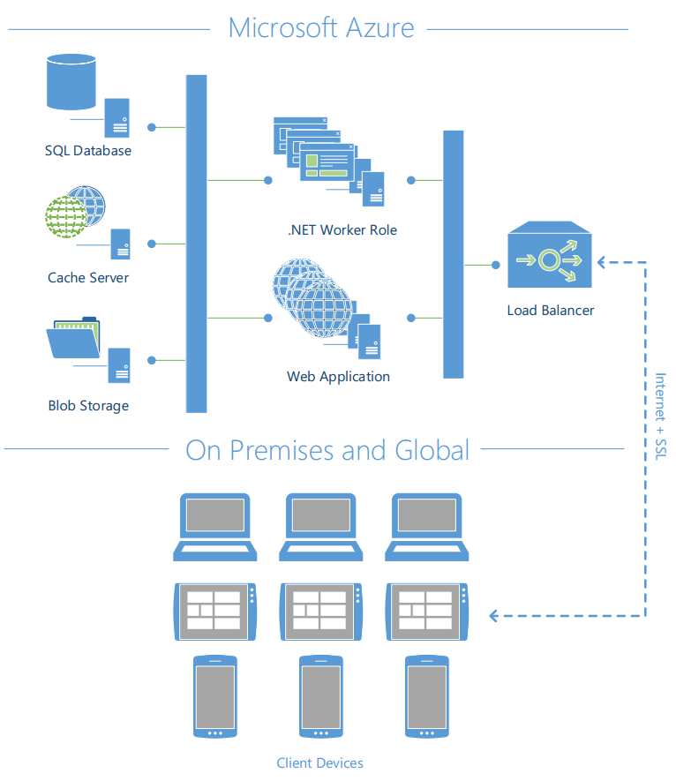

## Other technologies considered

Windows Azure – for customer portal

Other data access methods

Elements from earlier .NET frameworks